**User’s manual**

**Name:** Batbileg Munkh-Orgil **Neptune code:**P07GOF

**Chosen Homework assignment: “Morse code”**

**Goal of the program:**

* Code alphabetic text into Morse
* Decode Morse code into alphabetic text
* Show the statistics of the English alphabetic and Morse characters (dots and dashes)

**Requirements of the program:**

* Binary tree must be used when decoding Morse code into text
* Command line must be used to control coding and decoding
* File handling must be used
* The program must be portioned into several modules (at least two)

**Inputs of the program:**

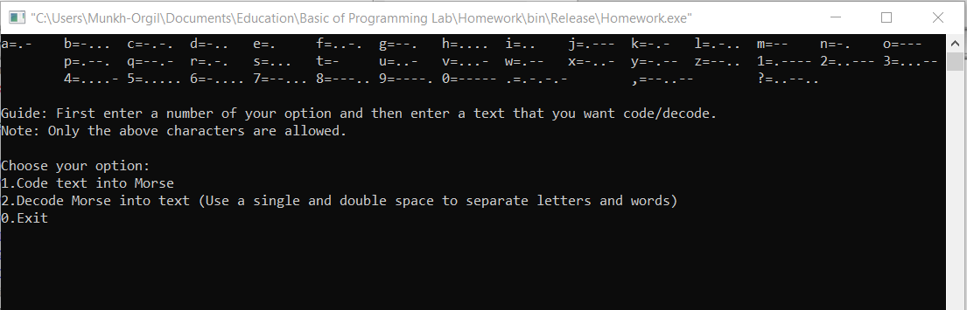1st input: user has to enter the number of the option that he/she chose.

1. Code text into Morse
2. Decode Morse into text
3. Exit

2nd input:

In case of 1. Code text into Morse:

* Enter alphabetic text into the program. / Ex: Hello world/

In case of 2. Decode Morse into text:

* Enter Morse code into the program. /Ex: …. . .-.. .-.. --- .-- --- .-. .-.. -.. / (two spaces separates words)

The steps stated above can be done several times until user enters 0

**Outputs of the program:**

In case of 1. Code text into Morse:

* Below entered text you can find Morse coded text.

/ Ex: …. . .-.. .-.. --- .-- --- .-. .-.. -.. /

In case of 2. Decode Morse into text:

* Below entered Morse you can find Alphabetic text decoded Morse.

/ Ex: Hello world /

In case of 3. Exit:

* The program will give statistics of all of you output variables: English alphabet letters and Morse characters (dots and dashes).
* Here the program ends